Built in Data Types
LO1
30-1-26
Aim – Demonstrate the use of list, dictionaries and tuples and how to add remove and edit the data stored in them.
Theory –
The first program has the append and pop functions which add and remove data from a list respectively, they also structure it according it to priority 1 to 3 as well as sorting the list. We use tuples to store the task and priority in the same index of the list.
Dictionaries are used in the next program to find the intersection, union and difference of the students appearing for neet, jee and cet. The functions are called by the sets and another set is given to the function to provide the required output.
The program is used to create update and manipulate a dictionary of student records including taking input and organizing their grades and attendance.
A1.
tasks = []

print("1-Add Task")
print("2-Remove Task")
print("3-Update Task")
print("4-Sort Tasks")
print("5-View All Tasks")
print("6-Exit")

while True:
print("Enter your choice (1-6): ", end="")
choice = int(input())

if choice == 1:
task_name = input("Enter task name: ")
priority = int(input("Enter priority (1-Highest/2-Medium/3-Lowest): "))
task = (task_name, priority)
tasks.append(task)
print(f"Task '{task_name}' added!")

elif choice == 2:
if not tasks:
print("No tasks to remove!")
else:
for i in range(len(tasks)):
print(f"{i}. {tasks[i][0]} - {tasks[i][1]}")
print("Enter task number to remove: ", end="")
idx = int(input())
if 0 <= idx < len(tasks):
removed = tasks.pop(idx)
print(f"Task '{removed[0]}' removed!")
else:
print("Invalid task number!")

elif choice == 3:
if not tasks:
print("No tasks to update!")
else:
for i in range(len(tasks)):
print(f"{i}. {tasks[i][0]} - {tasks[i][1]}")
print("Enter task number to update: ", end="")
idx = int(input())
if 0 <= idx < len(tasks):
new_name = input("Enter new task name: ")
new_priority = int(input("Enter new priority (1-Highest/2-Medium/3-Lowest): "))
tasks[idx] = (new_name, new_priority)
print("Task updated!")
else:
print("Invalid task number!")

elif choice == 4:
tasks.sort(key=lambda x: x[1])
print("Tasks sorted by priority!")

elif choice == 5:
if not tasks:
print("No tasks available!")
else:
print("\n--- All Tasks ---")
for i in range(len(tasks)):
print(f"{i}. {tasks[i][0]} - Priority: {tasks[i][1]}")

elif choice == 6:
print("Exit!")
break

else:
print("Invalid choice! Try again.")
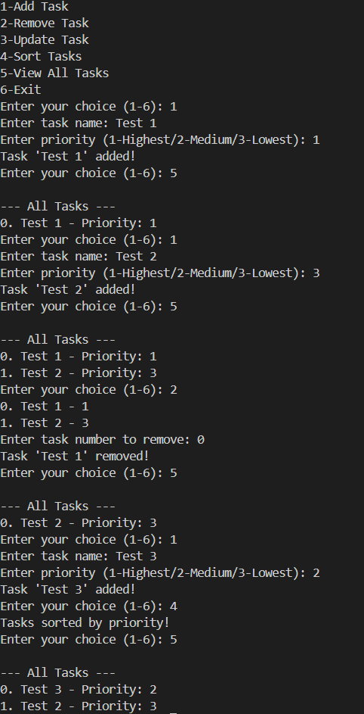
A2.
jee_students = {"Aarav", "Siddhant", "Vedant", "Chaitanya"}
cet_students = {"Siddhant", "Vedant", "Chaitanya", "Vikram"}
neet_students = {"Rohan", "Aarav", "Chaitanya", "Yuvraj"}

print(f"JEE Students: {jee_students}")
print(f"CET Students: {cet_students}")
print(f"NEET Students: {neet_students}")

(f"JEE union CET: {jee_students.union(cet_students)}")
print(f"JEE union NEET: {jee_students.union(neet_students)}")
print(f"CET union NEET: {cet_students.union(neet_students)}")

print(f"JEE intersection CET: {jee_students.intersection(cet_students)}")
print(f"JEE intersection NEET: {jee_students.intersection(neet_students)}")
print(f"CET intersection NEET: {cet_students.intersection(neet_students)}")

print(f"JEE - CET: {jee_students.difference(cet_students)}")
print(f"NEET - CET: {neet_students.difference(cet_students)}")
print(f"CET - JEE: {cet_students.difference(jee_students)}")
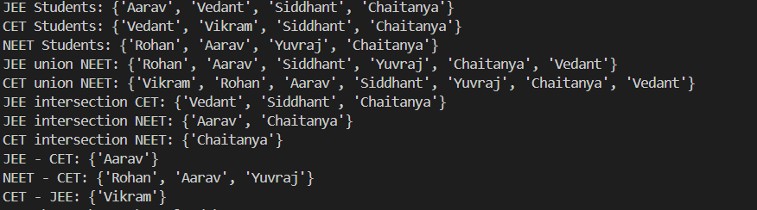
A3.
students = {}

while True:
print("\n--- Student Records Management ---")
print("1 - Add Student")
print("2 - Update Student")
print("3 - View All Students")
print("4 - View Specific Student")
print("5 - Delete Student")
print("6 - Exit")

choice = input("Enter your choice (1-6): ")

if choice == "1":
roll_no = input("Enter Roll Number: ")

if roll_no in students:
print("Student already exists!")
else:
name = input("Enter Name: ")
math_grade = float(input("Enter Math grade: "))
english_grade = float(input("Enter English grade: "))
science_grade = float(input("Enter Science grade: "))
attendance = float(input("Enter Attendance percentage: "))

grades = {
"Math": math_grade,
"English": english_grade,
"Science": science_grade
}

students[roll_no] = {
"name": name,
"grades": grades,
"attendance": attendance
}

print("Student added successfully!")

elif choice == "2":
roll_no = input("Enter Roll Number to update: ")

if roll_no not in students:
print("Student not found!")
else:
print("\nWhat do you want to update?")
print("1. Grades")
print("2. Attendance")

update_choice = input("Enter choice (1-2): ")

if update_choice == "1":
subject = input("Enter subject (Math/English/Science): ")
new_grade = float(input(f"Enter new {subject} grade: "))
students[roll_no]["grades"][subject] = new_grade
print("Grade updated!")

elif update_choice == "2":
new_attendance = float(input("Enter new attendance: "))
students[roll_no]["attendance"] = new_attendance
print("Attendance updated!")

elif choice == "3":
if not students:
print("No students in records!")
else:
print("\n--- All Students ---")
for roll, details in students.items():
print(f"\nRoll No: {roll}")
print(f"Name: {details['name']}")
print(f"Grades: {details['grades']}")
print(f"Attendance: {details['attendance']}%")

elif choice == "4":
roll_no = input("Enter Roll Number: ")

if roll_no not in students:
print("Student not found!")
else:
details = students[roll_no]
print(f"\n--- Student Details ---")
print(f"Roll No: {roll_no}")
print(f"Name: {details['name']}")
print(f"Grades: {details['grades']}")
print(f"Attendance: {details['attendance']}%")

elif choice == "5":
roll_no = input("Enter Roll Number to delete: ")

if roll_no not in students:
print("Student not found!")
else:
del students[roll_no]
print("Student deleted successfully!")

elif choice == "6":
print("Exiting...")
break

else:
print("Invalid choice! Please try again.")

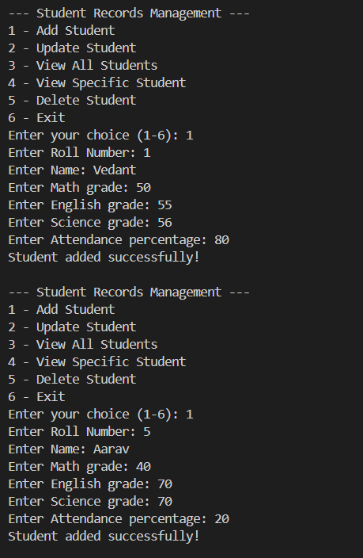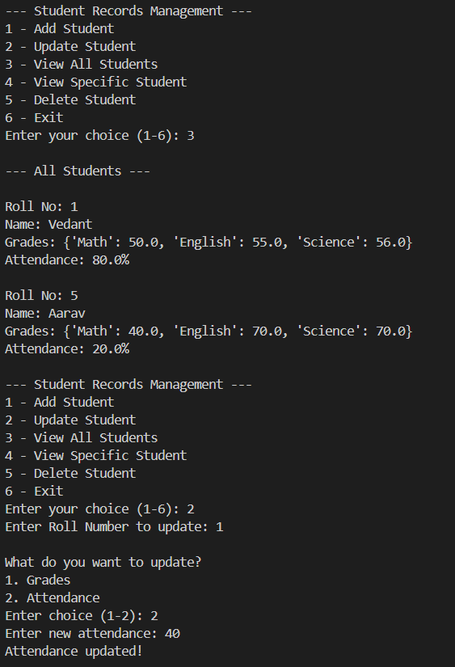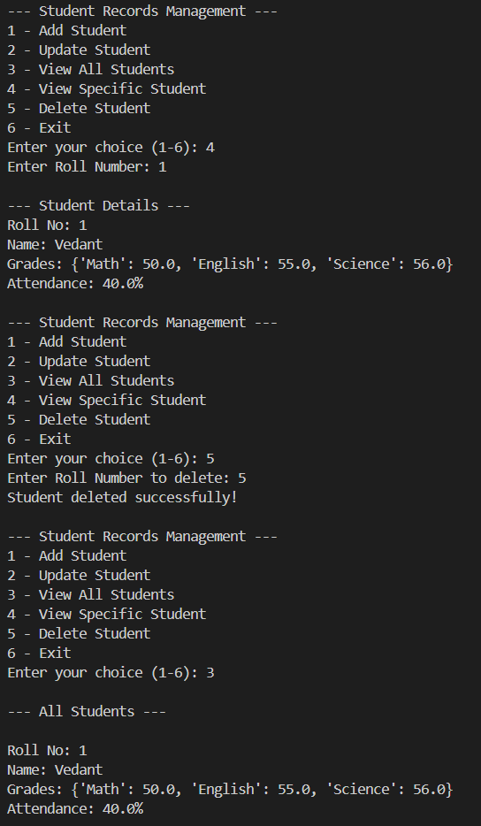
Conclusion
It demonstrates the practical use of lists, sets and dictionaries in python. It creates a menu driven program using for loops, logical flow and user interaction. It shows is how to efficiently organize data and exam records. It gives us practical problem solving using pythons core concepts.

